**Assignment 2**

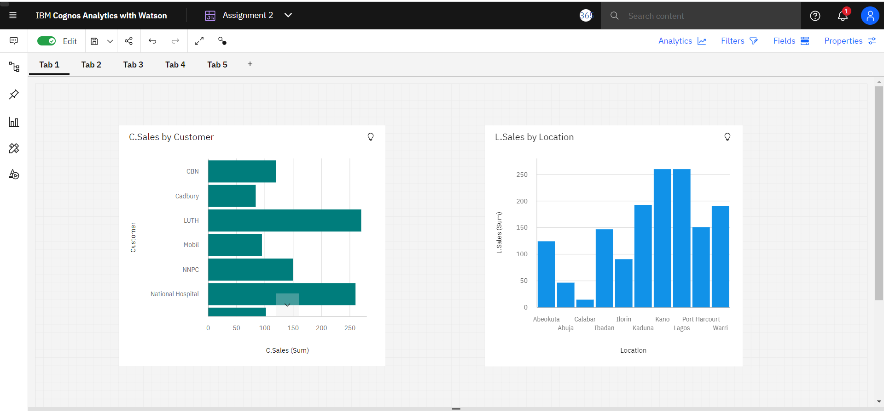

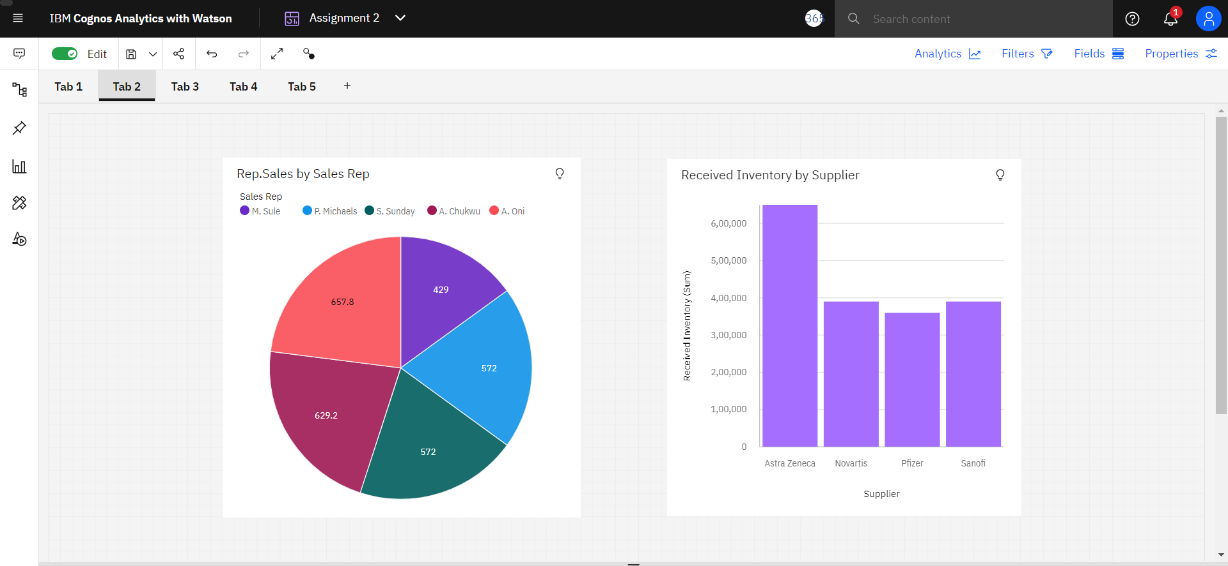

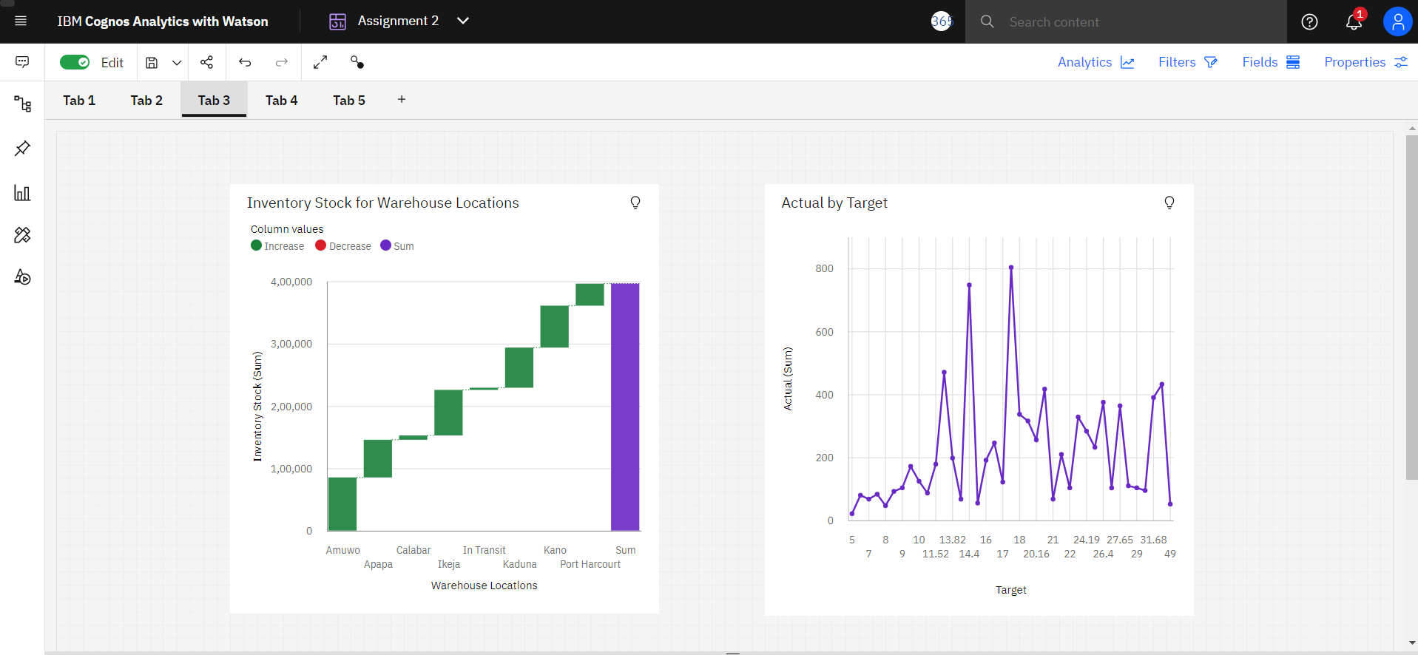

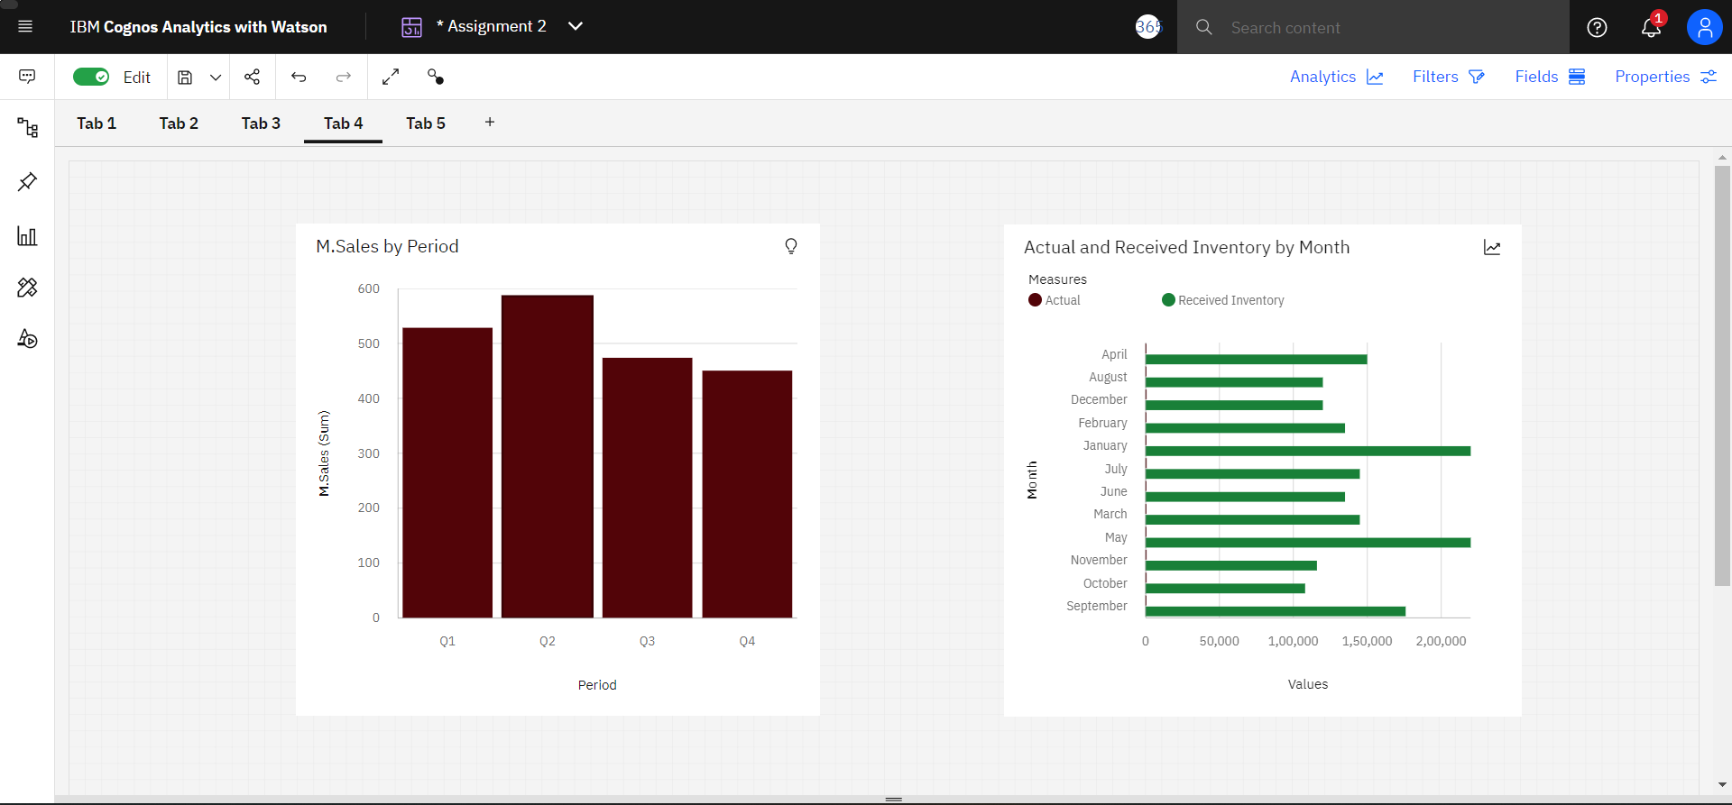

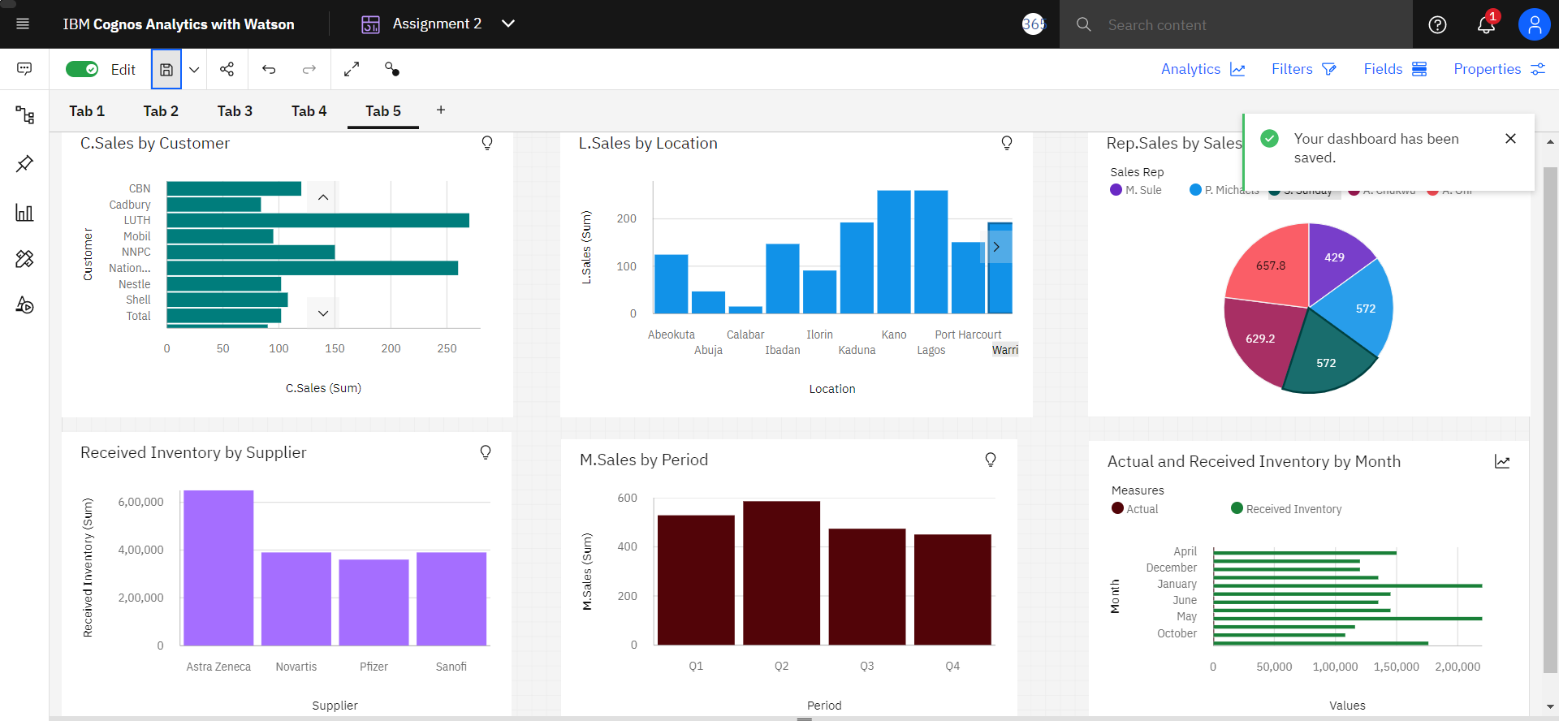

**Link:**

https://us1.ca.analytics.ibm.com/bi/?perspective=dashboard&pathRef=.my_folders%2FAssignment%2B2&action=view&mode=dashboard&subView=model00000183c2b80ab5_00000000